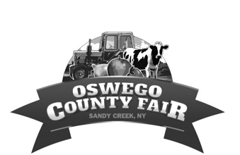
Stall Rental & Camping Agreement
Oswego County Fairgrounds
291 Ellisburg St. Sandy Creek, NY
NBHA NY 07 Barrel Racing events 2024
These fees are non refundable after reservations have been made unless stalls are completely sold out or the event is cancelled by the event host.
Payment and Form Submission options: Please complete this form and submit it via email or mail
Mail to: Oswego County Fair Association PO BOX 87 Lacona, NY 13083
Email to: Oswegocountyagriculturalsociety@gmail.com
Facebook Messenger to: Oswego County Fair

You are responsible to set up your own stall. Names will be placed on stall doors before the event, in order of completed forms. If you have any trouble locating your stall door please contact the fair office, via phone 315-247-8352, in person or send a message via facebook messenger.
Stalls need to be striped clean once you are done using them. If they are not cleaned you will be subject to a $25 cleaning fee which will be billed to you.
Stalls and hook ups are $20 per day or $30 for the weekend. Arrival is permitted at 4 pm Friday for Saturday events and 4 pm Saturday for Sunday events.
Name: ____________________________ Phone Number: ____________________
Address: ___________________________
Request (circle one): Night:$20 or Weekendl:$30 # Stalls requested:__ Total due for Stalls: $_____
Trailer tie out or paddock set up: $10 _____
-Tie out to trailer or paddock set up

Water & Electric Hookup: $25 _____
-Fee for Water and Electric Hookup_

Electric Hookup: $15 _____
-Fee for just Electric Hookup Total $________
Payment Type Cash _____ Check ______ Credit Card_____ Date _____________________
*By signing this agreement, you agree to the fees and requirements made on it. You also agree to hold the Oswego County Fair Association/Oswego Agricultural Society and its Officers and Board members harmless for lost, damaged or stolen items as well as any physical or bodily injury to you, your horse or pets while on the grounds. All Doges & Horse must have current coggins and rabies certificates.

Signed (must be 18 years or older): ____________________________________________

